|  |
| --- |
| **Consulting** |
| Addon Install, Uninstall and Upgrade  Quick Guide |
|  |

 



Content

Installation Guide 3

1.1 Windows Folders Security Permission 3

Lightweight Installation Procedure 4

1.2 How to install it in the Server 4

1.3 How to assign it to a Company 5

Uninstall and Unassing 9

1.4 How to unassing it from the Company 9

1.5 How to uninstall it from the Server 9

Upgrade 10

# Installation Guide

In this document, you will find how to install and uninstall WMS in the SBO Server, assign and unassign it to a company.

## Windows Folders Security Permission

The add-on will need permission to create folders and write files during the installation, upgrade and also when using the different features WMS provides. These permissions depend on the Windows User that is logged in.

The default installation path for SAP Business One Client 32 bits is in C:\Program Files (x86)\SAP\SAP Business One\AddOns\ARGNS\WMS-Addon-Base. The default installation path for SAP Business One Client 64 bits is in C:\Program Files (x64)\SAP\SAP Business One\AddOns\ARGNS\ WMS-Addon-Base. However; the folders under the “Program Files (x86) & Program Files” directories have some restrictions to the common Windows Users and Users Group. Unless you manually change the security permissions in the folder under the “ARGNS” directory, you will need to install the Add-on in a directory where the Windows Users are allowed to Read, Execute & Write.

In case it is decided to install the add-on in the default path, please verify the Windows Users that are going to run the SAP Business One application have the permissions mentioned before.

It is important to remember that every time the add-on is installed or upgraded, the folder “WMS-Addon-Base” and all its subfolders and files are deleted and created again so the permissions might be modified. That is why it is suggested to provide the permissions in the root folder “ARGNS” (that it is not deleted during an upgrade or re-installation) and also check that inheritance is enabled.

Security permissions for “ARGNS” should look like the following screenshot:

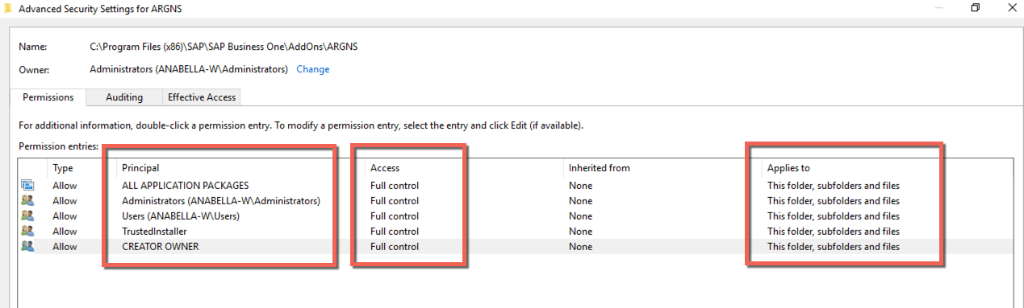

# Lightweight Installation Procedure

## How to install it in the Server

To install the add-on through the lightweight method, go to Add-on Administration →Manage Extensions for Lightweight Deployment.

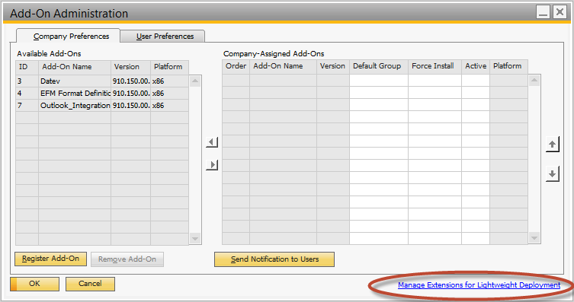

Enter the B1SiteUser and password to login

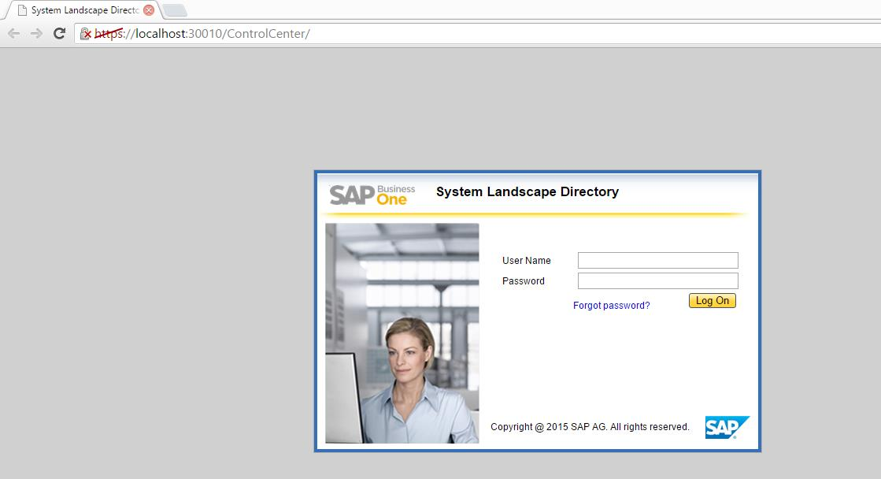

Click on Import and browse the addon .zip file that is in the AddonWMS folder. Then, click on Upload.

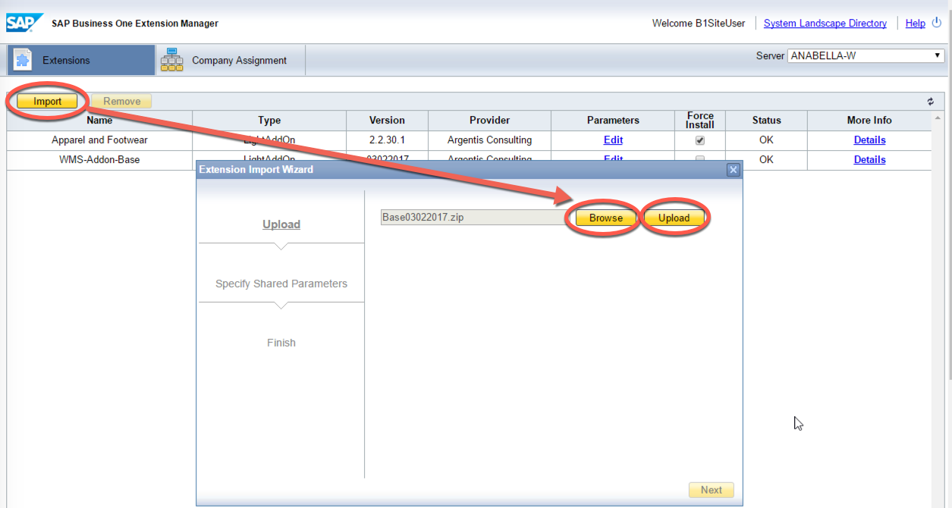

Once the file is uploaded check the status:

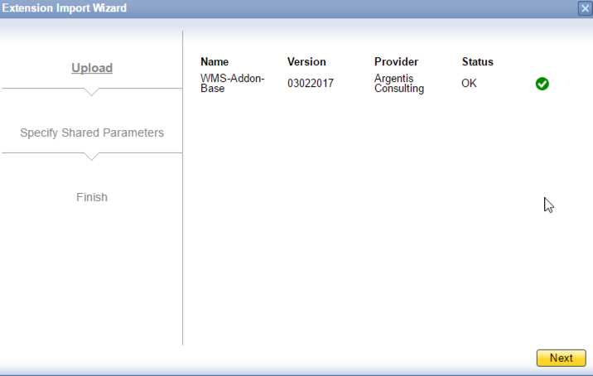

## How to assign it to a Company

Next assign the Addon on to the SAP Company Database

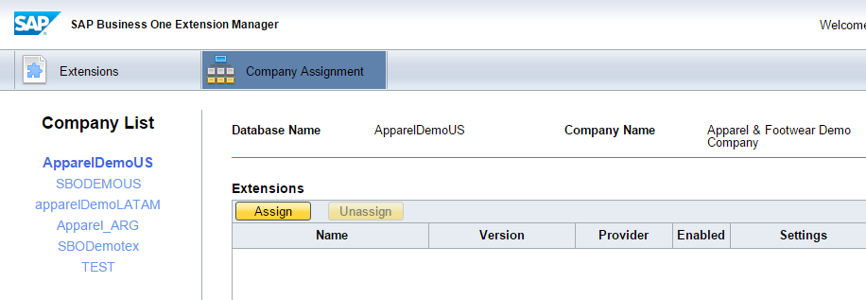

Select the solution and click next:

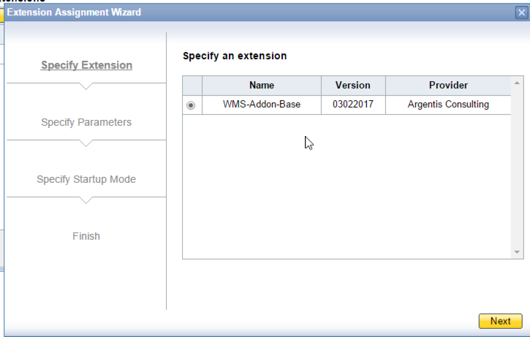

Assign the user defaults for startup mode

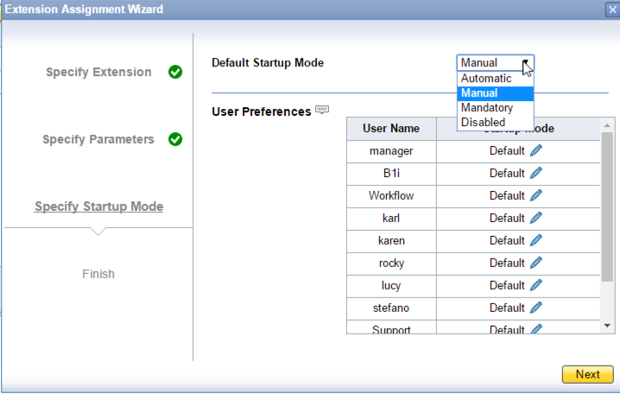

Login to the company and after a few seconds you will receive this message: “Add-on WMS-Addon-Base was successfully installed”

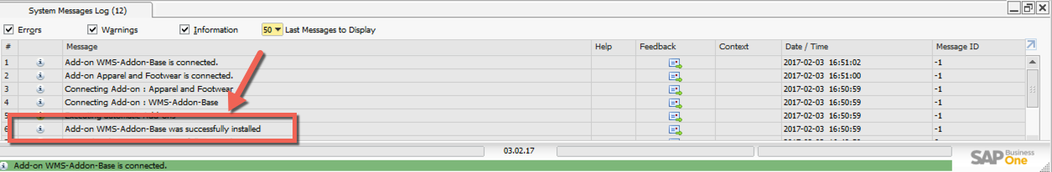

After the message, you will find that the add-on is available in the Add-On Manager Window:

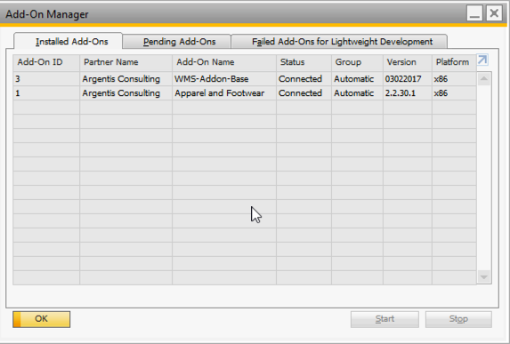

# Uninstall and Unassing

## How to unassing it from the Company

To unassnig the add on from the company select the solution and click on the unassign option:

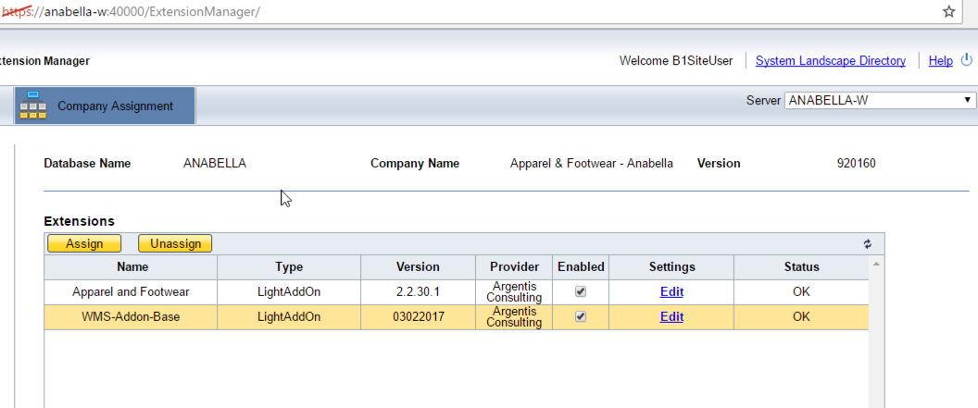

## How to uninstall it from the Server

To uninstall the Add On, select the solution and click on the Remove

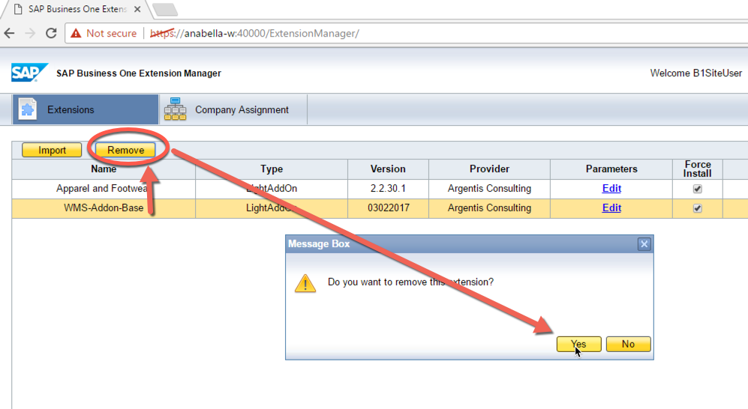

Log in again in the SAP Client and a message in the System Messages Log will say:

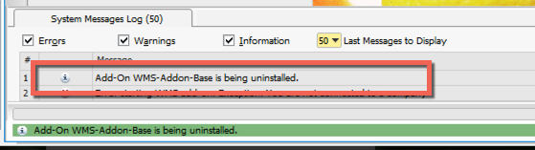

# Upgrade

To upgrade the add-on, first delete the older version from the server, then re-install it again and assign it to the corresponding companies.